MSCAST ERP — Demo Run-sheet

MSCAST ERP — Demo Run-sheet
For: the MSCAST walkthrough · Version: 1.1 · Date: 21 September 2026
How to pitch it: “This is our reading of your requirements. Correct us.” Every screen below ends with a question for MSCAST. Their answers matter more than the demo does.
- Length: about 45 minutes, 10 stops. Stop 6 is the one to protect if time runs short.
- Each stop gives: who is logged in, where to click, what to say (two or three points) and what to ask.
- The pictures were taken on DEV on 21 September 2026. What you see on the day should match them.

Before the meeting
- Use the DEV instance: https://mscastdev.carobar.net
  - The Live POC (https://mscast.carobar.net) is being tried by MSCAST staff with their own logins; most demo logins no longer exist there. Nobody changes live without the owner’s say-so.
  - DEV is a separate copy (own database, same image) with the full demo cast. Nothing done in the meeting touches live.
  - An orange DEV INSTANCE banner runs along the top of every page. Say once: “this is our test copy”, and move on.
- One browser window per person (Chrome profiles or incognito windows). Each login allows only two sessions at a time; a third logs out the oldest.
- Log in beforehand as Mustaque, Meera, Anita and S. Joshi, and keep the four windows open.
- Passwords are shared separately and are not written in this sheet.
- Five minutes before: open the home page as Mustaque. If the cards load, everything is up.

The cast
Person | What they do | Login on DEV
Mustaque Chandankeri | Director (approves) | latookaushik@yahoo.com
Aiqaz Chandankeri | Director (backup) | latookaushik@hotmail.com
Anita Deshpande | Accounts Manager | carobar.tradecars@gmail.com
Meera Rane | Design draughtsman | meera.rane@mscast.co.in
S. Joshi | Chartered Accountant (read-only) | autoelectron.jp+ca@gmail.com
Rohit Kulkarni | Prepares cost sheets (named on the PCC) | not logged in during the demo
The directors are MSCAST’s real directors. Everyone else is a demo face, and only the names change at go-live.

Stop 1 — The director’s morning
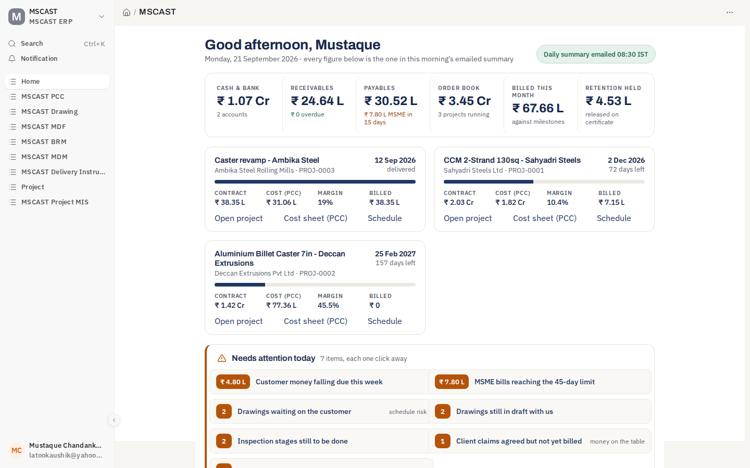
Home page as Mustaque
- Login: Mustaque.
- Click: sidebar → Home.
- Say:
  - One page answers “where do we stand?”: cash ₹1.07 Cr, receivables ₹24.64 L, payables ₹30.52 L, order book ₹3.45 Cr, retention held ₹4.53 L.
  - Each project card shows contract, cost, margin and billing against its delivery date.
  - “Needs attention today” lists seven items, one click each. Money falling due, MSME bills nearing 45 days, drawings stuck with the customer.
  - The same figures reach his inbox at 08:30 IST, so he doesn’t have to log in to know.
- Ask:
  - Is this what you look at first thing? What’s missing, and what could go?
  - Who else should get the 08:30 summary?

Stop 2 — The cost sheet (PCC)
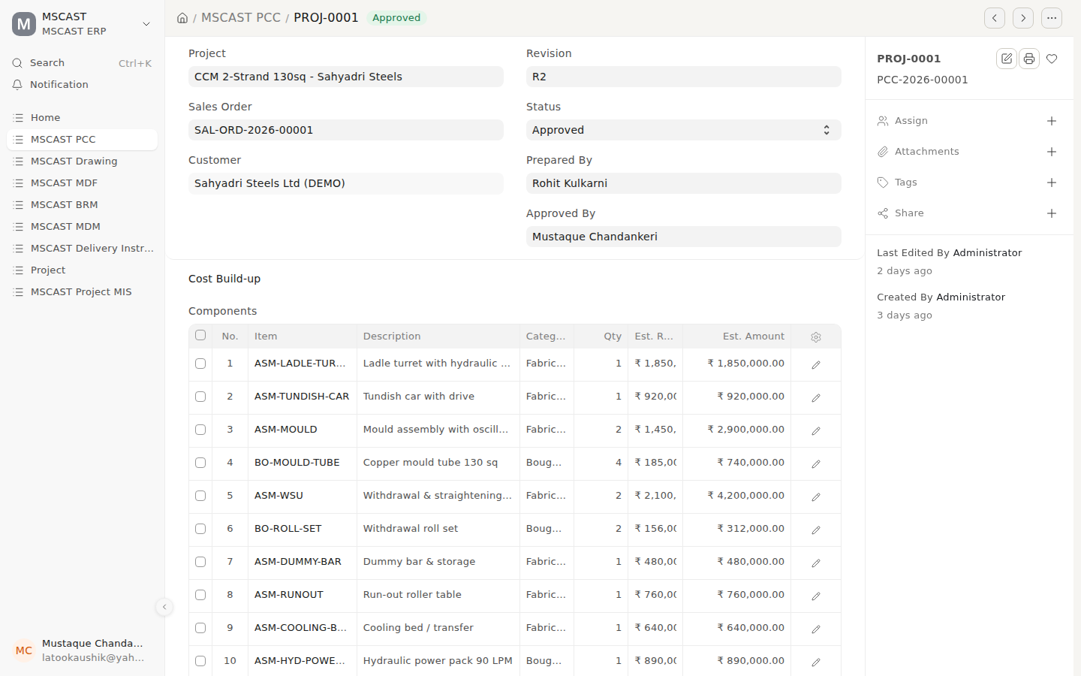
PCC-2026-00001, approved
- Login: Mustaque.
- Click: sidebar → MSCAST PCC → PCC-2026-00001 (PROJ-0001, CCM 2-Strand 130sq for Sahyadri Steels).
- Say:
  - Built up component by component: ladle turret, tundish car, mould, WSU and so on. Each line is marked fabricated or bought-out.
  - It’s on revision R2. Rohit prepared it, Mustaque approved it, and the system records both.
  - An approved PCC is locked. A change means a new revision, and the old one stays on file.
- Show the print: printer icon → format MSCAST PCC Sheet.
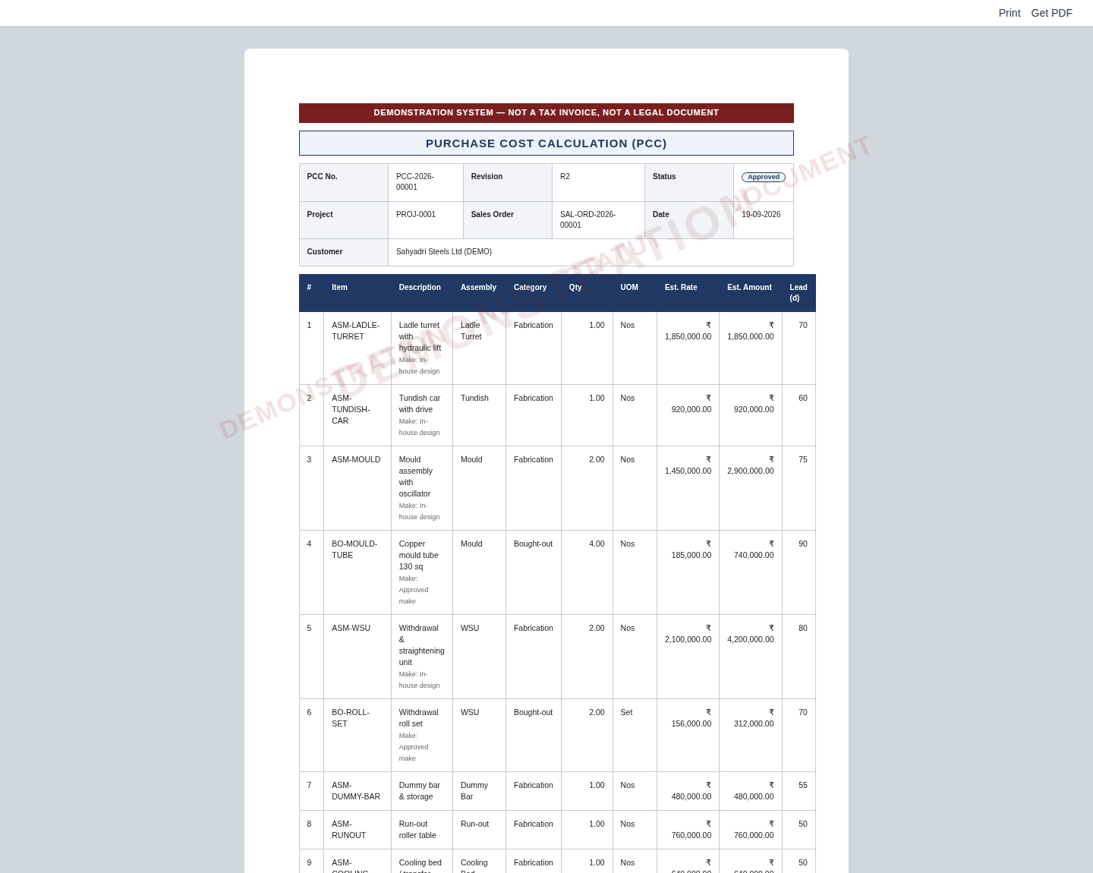
The PCC as printed
- Ask:
  - This layout is our guess. Can we have a real PCC of yours, even a photo of a filled-in sheet?
  - Who prepares it today, and does a director always approve it?

Stop 3 — Kick-off held: the customer PO doesn’t match our offer
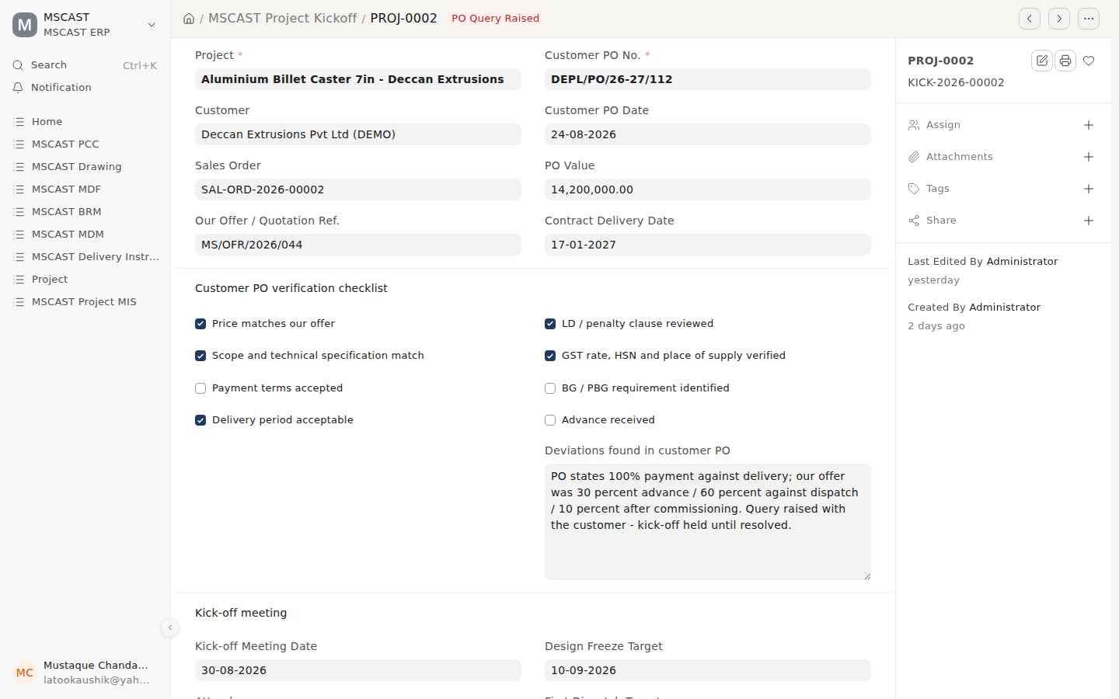
KICK-2026-00002, PO Query Raised
- Login: Mustaque.
- Click: search bar (Ctrl+K) → MSCAST Project Kickoff → KICK-2026-00002 (Deccan Extrusions, PROJ-0002).
- Say:
  - Before a project starts, someone checks the customer’s PO against our offer, point by point.
  - Here the PO says 100% payment on delivery. Our offer was 30% advance, 60% on dispatch and 10% after commissioning. The kick-off is held, status PO Query Raised.
  - The kick-off cannot be approved until the checklist is complete. The system is doing its most valuable job here.
- Ask:
  - Is this checklist right? What else do you check on a customer PO: LD clauses, PBG, advance?
  - Who does this check today?

Stop 4 — Drawings, and who is waiting on whom
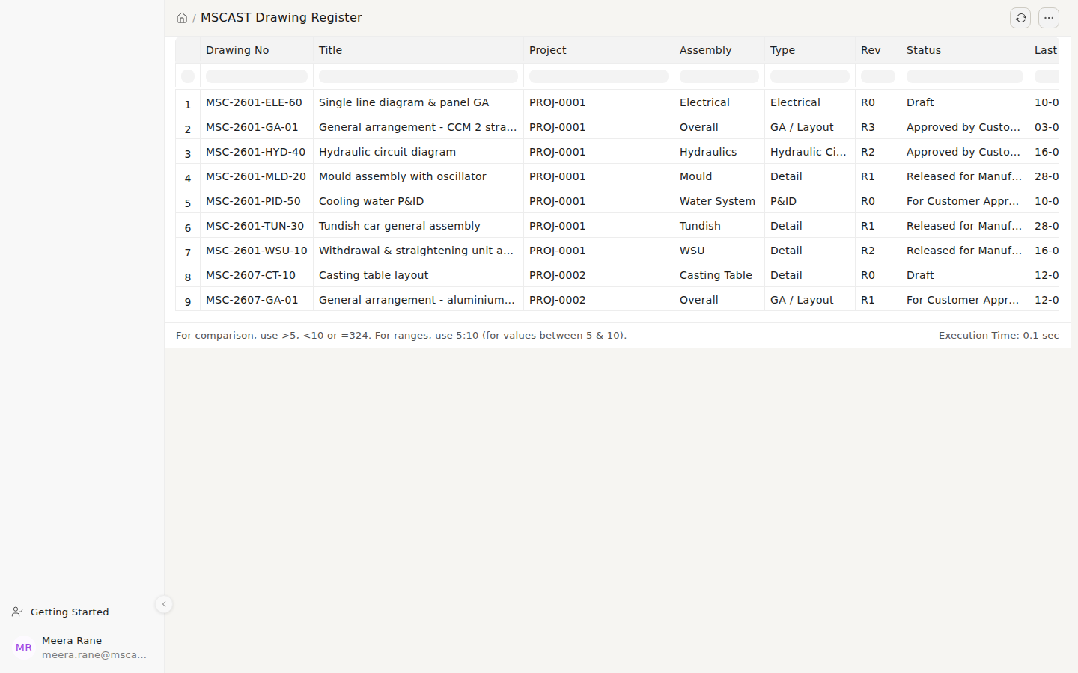
Drawing Register as Meera
- Login: Meera (switch windows).
- Click: search bar → MSCAST Drawing Register.
- Say:
  - Every drawing shows its number, revision and status: Draft, For Customer Approval, Approved by Customer, Released for Manufacture.
  - Meera sees her own work. She doesn’t see the books.
- Then: open MSC-2601-PID-50 (Cooling water P&ID), which is waiting on the customer.
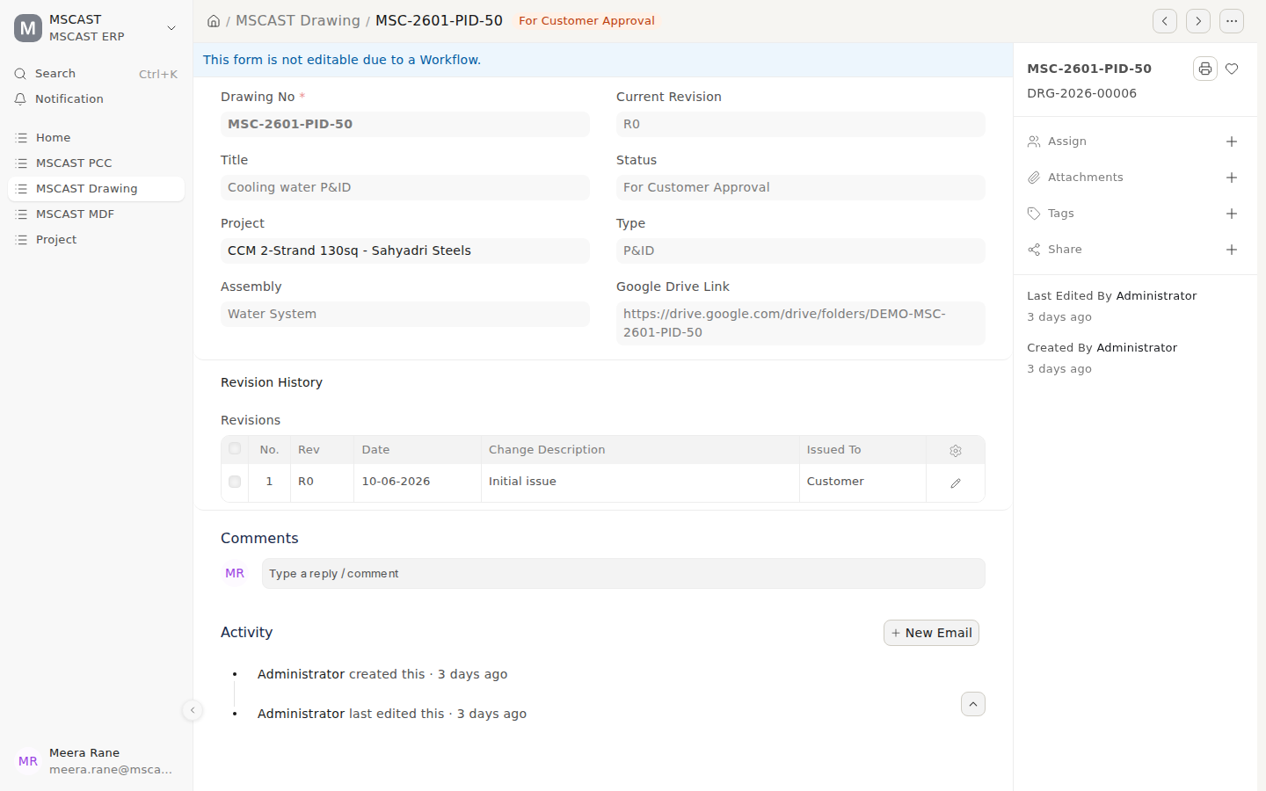
A drawing waiting on the customer
- Say:
  - A drawing cannot be released for manufacture until the customer has approved it. Only a Projects Manager can release it.
  - The revision history and the Google Drive link travel with the record.
- Ask:
  - How do you number drawings today? Is MSC-YYNN-XXX-NN close?
  - Do customers approve by email, on a transmittal, or by marking up prints?

Stop 5 — The purchase order
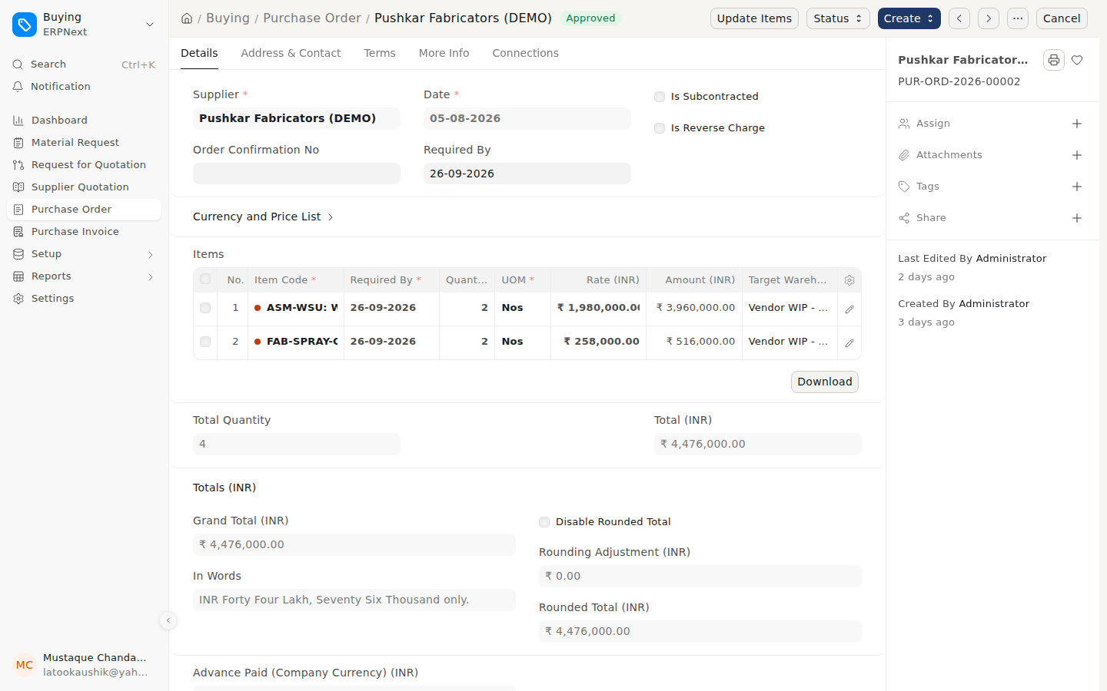
PUR-ORD-2026-00002, approved
- Login: Mustaque.
- Click: search bar → Purchase Order → PUR-ORD-2026-00002 (Pushkar Fabricators, ₹44.76 L).
- Say:
  - Purchase raises the PO and a director approves it.
  - A PO cannot be approved unless someone in Purchase sent it, so every PO passes through two people.
- Ask:
  - Is there a value below which a PO doesn’t need a director?

Stop 6 — The BRM: no certified memo, no payment (the headline)
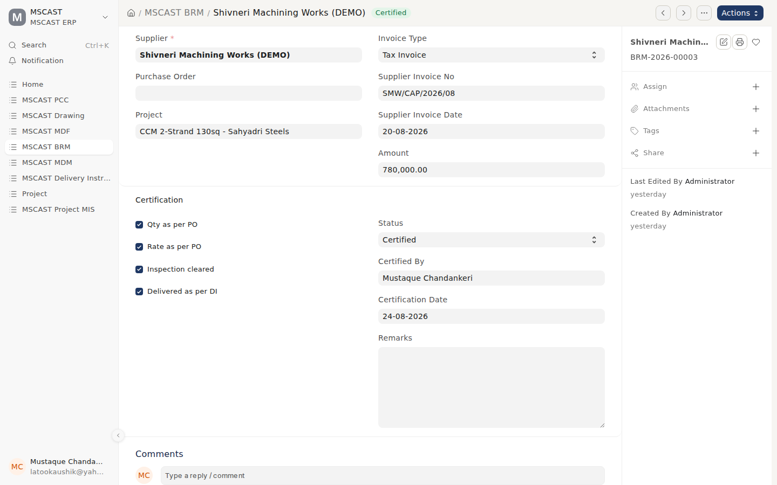
BRM-2026-00003, certified with its four checks
- Login: Mustaque.
- Click: sidebar → MSCAST BRM → BRM-2026-00003 (Shivneri Machining Works, ₹7.80 L).
- Say:
  - The Billing Routing Memo is MSCAST’s own control. Before a supplier bill is paid, someone certifies quantity, rate, inspection and delivery against the PO.
  - All four boxes are ticked, and the memo shows who certified it and when.
  - The system will not accept “Certified” with a box left unticked (build check T6n).
- Now the moment: switch to Anita and open Payment Entry ACC-PAY-2026-00003 (Ashoka Heavy Fabricators, ₹2,85,600). It is a draft. Click Submit.
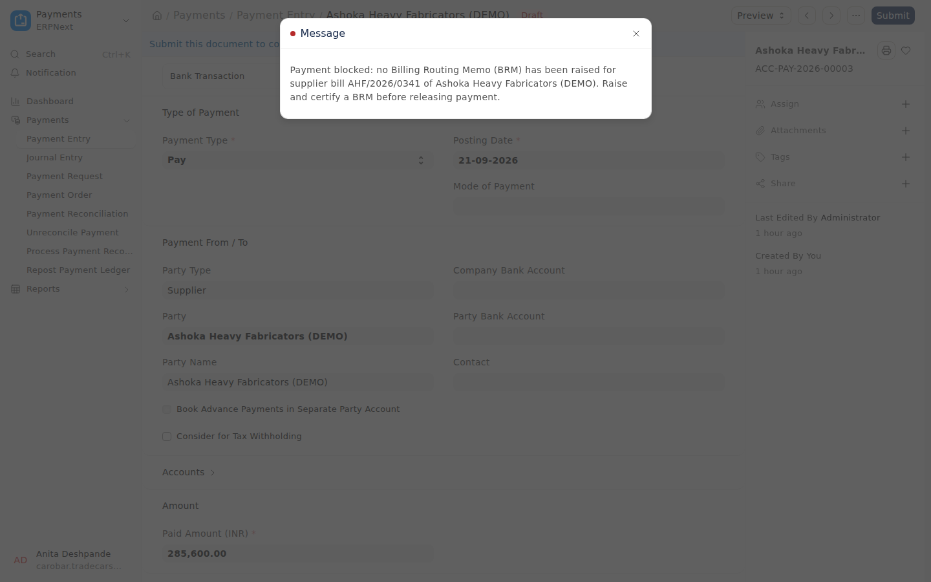
Payment refused: no certified BRM
- Say:
  - “Payment blocked: no BRM has been raised for supplier bill AHF/2026/0341.”
  - It applies to everyone: not at month end, not under pressure from the supplier, not through a journal entry either.
  - The payment stays a draft, so you can show this as often as you like.
- Then: search bar → MSCAST BRM Register (as Anita).
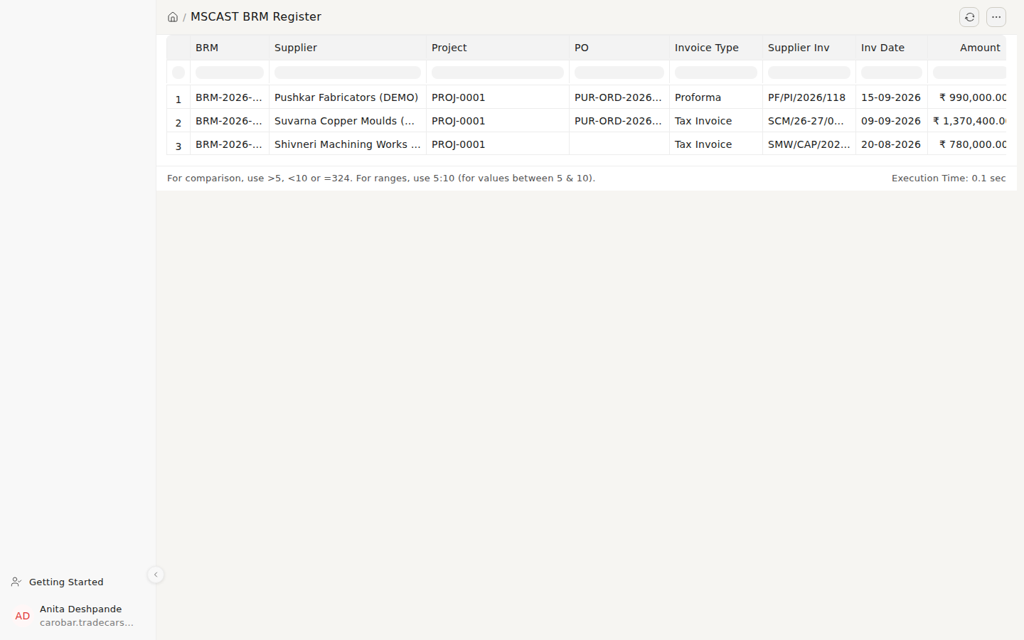
BRM Register
- Ask:
  - Which suppliers, if any, should be exempt: utilities, statutory dues, petty cash?
  - Can we have a real BRM of yours to copy the layout from?
  - Today a director can prepare, certify and pay a BRM alone. Is that intended? (Q21)

Stop 7 — Dispatch and the proforma
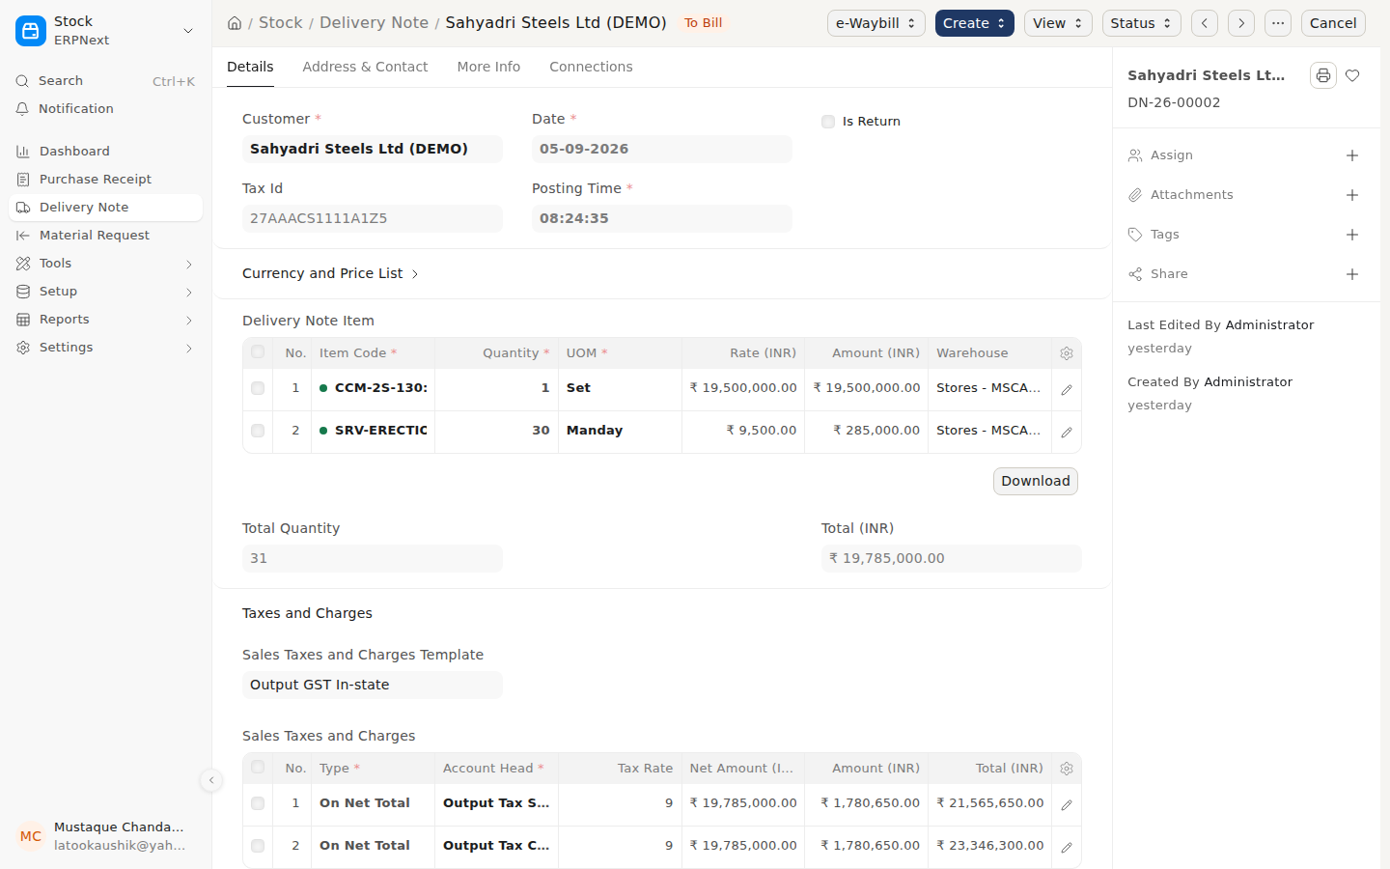
DN-26-00002 to Sahyadri Steels
- Login: Mustaque.
- Click: search bar → Delivery Note → DN-26-00002 (Sahyadri Steels, CCM-2S-130 plus erection supervision).
- Say: the machine is dispatched against the sales order, and GST is calculated and posted to the right heads automatically.
- Then: open Sales Order SAL-ORD-2026-00001 → printer icon → MSCAST Proforma Invoice.
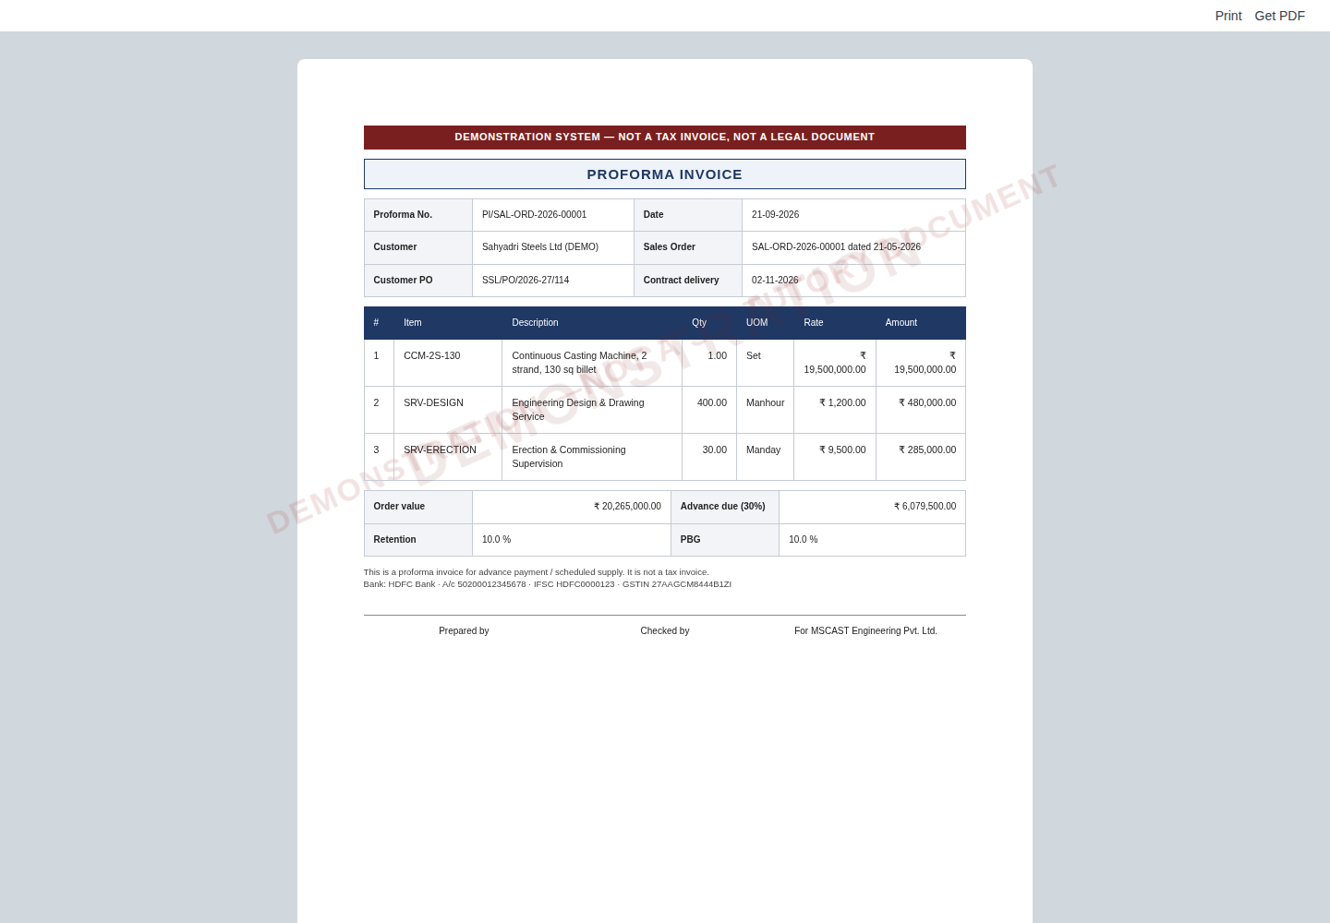
Proforma invoice (demo watermark)
- Say:
  - The advance due (30%) is worked out from the order. Retention and PBG percentages are carried from the contract.
  - Every print carries a DEMONSTRATION watermark on this system.
- Ask:
  - What do your MDM, Delivery Instruction and Annexure-I look like? A sample of each, please.

Stop 8 — Project MIS
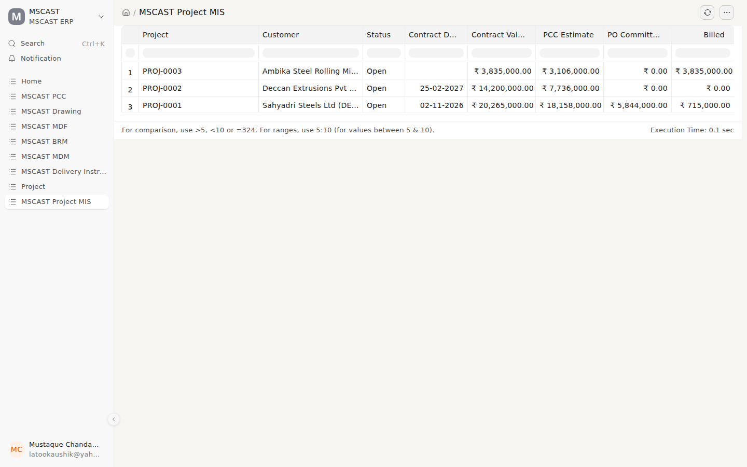
Project MIS
- Login: Mustaque.
- Click: sidebar → MSCAST Project MIS.
- Say: one line per project: contract value, PCC estimate, PO commitments, billed. Estimate against commitment is where the margin is lost or kept.
- Ask:
  - What columns does your MIS have today? Please send us the actual format.

Stop 9 — MSME 45-day dues
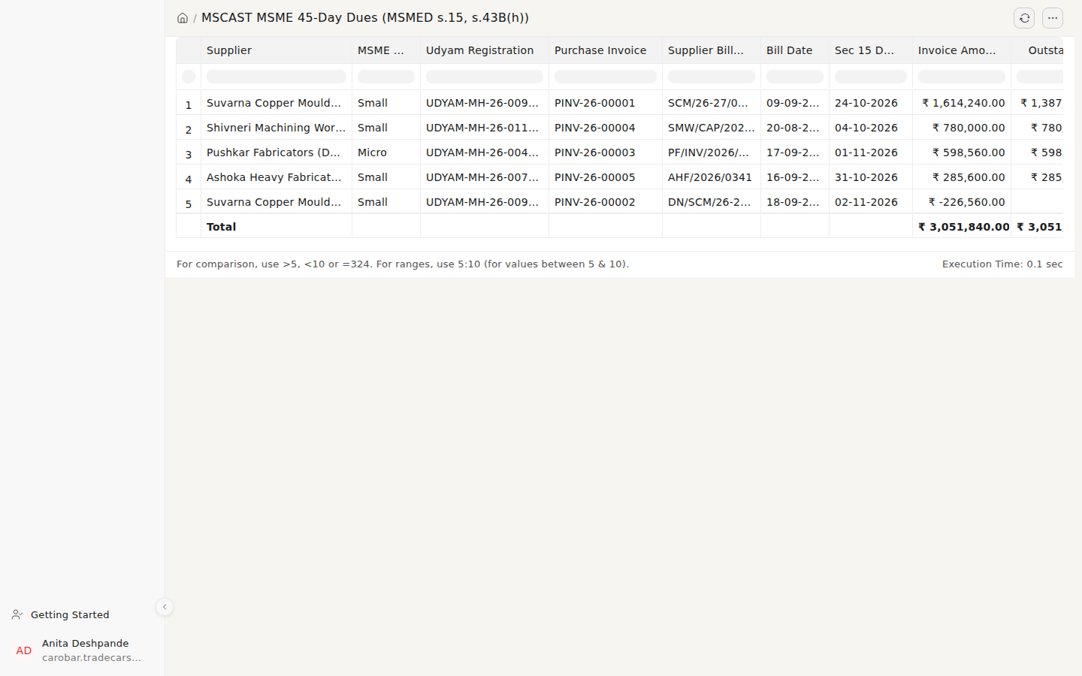
MSME 45-Day Dues
- Login: Anita.
- Click: search bar → MSCAST MSME 45-Day Dues.
- Say:
  - A payment to an MSME supplier made after 45 days cannot be deducted for income tax in that year (s.43B(h)). The report shows each bill’s deadline, using each supplier’s Udyam registration.
  - The home page shows the same figure as a warning: ₹7.80 L within 15 days.
- Ask:
  - Do you have Udyam numbers for your suppliers? Which of them are micro or small?

Stop 10 — The CA’s view: read everything, change nothing
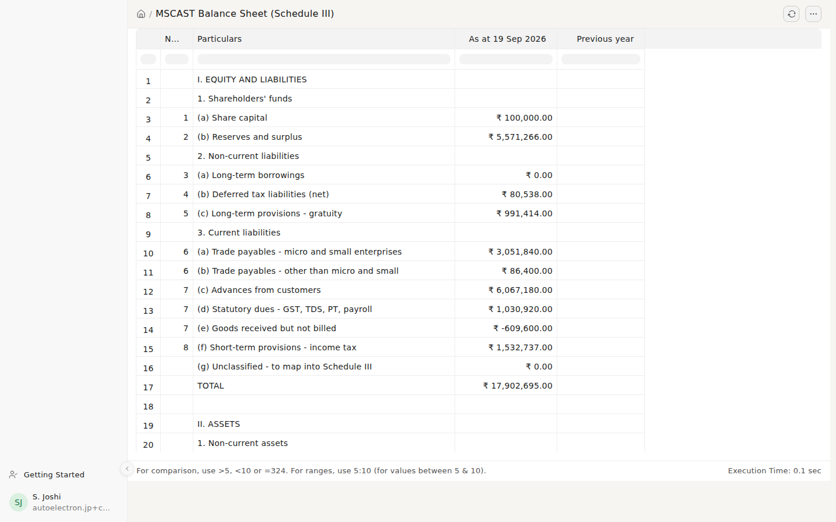
Balance Sheet, Schedule III
- Login: S. Joshi (the CA).
- Click: search bar → MSCAST Balance Sheet (Schedule III).
- Say:
  - Laid out in the Schedule III format. MSME payables are shown separately, as the law requires.
  - The CA can open anything.
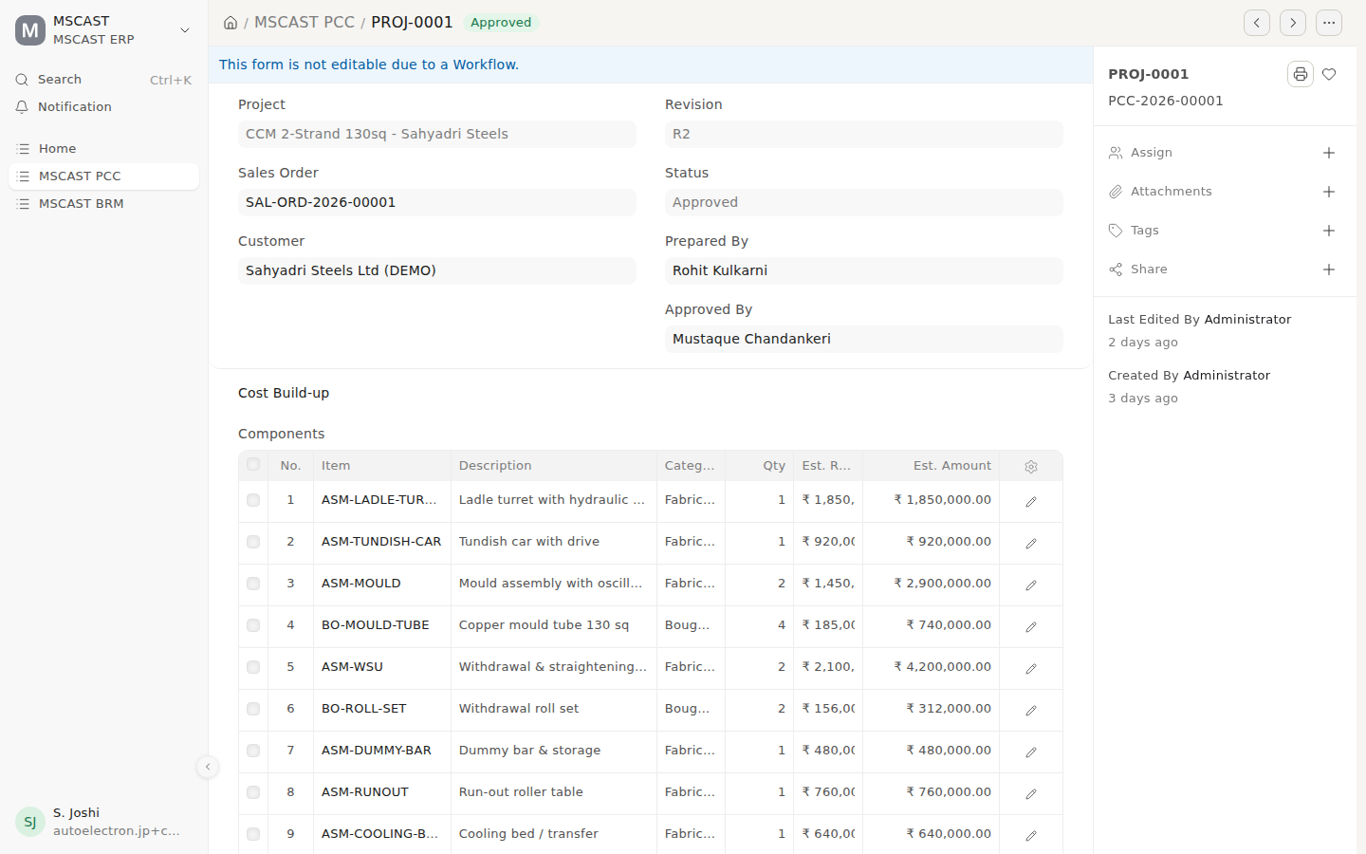
The CA opens a PCC: read-only
- Say: the same PCC as in Stop 2, but the CA cannot change it. No auditor role can create, edit or delete anything, and the audit trail cannot be switched off.
- Ask:
  - Who is your CA? We’d like them to review the chart of accounts and opening balances before go-live.

Questions to leave with MSCAST
# | Question | Why it matters
1 | Real formats: PCC, Project MIS, BRM, MDM with DI and Annexure-I (photos are fine) | Today the system carries our reading of them, not yours
2 | Q20: a director can prepare a PCC or verify a PO and then approve it alone. Intended? | Segregation of duties
3 | Q21: a director can create, certify and pay a BRM alone. Intended? | That is the step that releases money
4 | Suppliers exempt from the BRM rule, if any | Otherwise every payment needs one
5 | Who owns the monthly jobs: MSME review, GST, close | A control nobody runs is not a control
6 | Tally: which year, and who exports the masters and balances | Opening balances must match Tally to the rupee
7 | CA name and contact | Sign-off on the books before go-live
8 | PO value limit, if any, below which a director needn’t approve | Speeds up small purchases

Rough edges: say them before anyone finds them
- Screens don’t refresh by themselves over this link. Press F5 to see someone else’s change. It’s a setting in the public link, not in the ERP, and it goes away on a proper server.
- Balance sheet: “Goods received but not billed” shows ₹ −6.10 L. A negative there is impossible in real books. It comes from the way the demo entries were loaded (receipts and bills entered without their real sequence). Point it out yourself: “this is exactly what the CA review catches.”
- MSME report: one row shows ₹ −2,26,560. The bill reference starts DN/, so it is a debit note (goods returned) against that supplier, not a bill. Real data won’t carry it.
- The proforma carries MSCAST’s real GSTIN. It’s on a demo system, so every print is watermarked DEMONSTRATION and none of them is a tax invoice.
- Logins are placeholder email addresses. Real staff get their own at go-live, and only the names change.
- The orange DEV banner is the test copy’s marker. Production won’t have it.

After the meeting
- Write down every correction MSCAST gives, stop by stop. Those corrections are the real output of the meeting.
- Nothing needs resetting. The payment in Stop 6 stays a draft, and nothing else is changed by the walkthrough.
- If anything was changed on DEV, it can be rebuilt from its saved copy in about ten minutes (dev-create.sh). Live is never affected.

